Exercise 1: Implementation of Singleton Pattern
Program:
public class Main {

static class Logger {
private static Logger instance;
private Logger() {
System.out.println("Logger initialized.");
}

public static Logger getInstance() {
if (instance == null) {
instance = new Logger();
}
return instance;
}

public void log(String message) {
System.out.println("Log: " + message);
}
}

public static void main(String[] args) {
Logger logger1 = Logger.getInstance();
logger1.log("First log message.");

Logger logger2 = Logger.getInstance();
logger2.log("Second log message.");

if (logger1 == logger2) {
System.out.println("Both logger instances are the same (singleton confirmed).");
} else {
System.out.println("Different instances exist (singleton failed).");
}
}
}

Output:
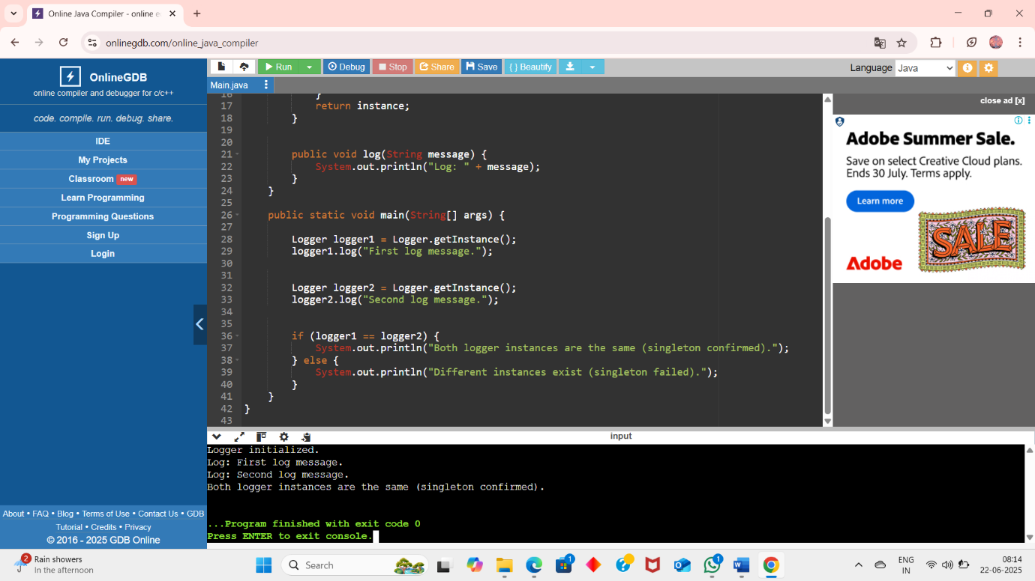

Exercise 2 : Implementing the Factory Method Pattern
Program:

interface Document {
void open();
}

class WordDocument implements Document {
public void open() {
System.out.println("Opening a Word document.");
}
}

class PdfDocument implements Document {
public void open() {
System.out.println("Opening a PDF document.");
}
}

class ExcelDocument implements Document {
public void open() {
System.out.println("Opening an Excel document.");
}
}

abstract class DocumentFactory {
public abstract Document createDocument();
}

class WordDocumentFactory extends DocumentFactory {
public Document createDocument() {
return new WordDocument();
}
}

class PdfDocumentFactory extends DocumentFactory {
public Document createDocument() {
return new PdfDocument();
}
}

class ExcelDocumentFactory extends DocumentFactory {
public Document createDocument() {
return new ExcelDocument();
}
}

public class Main {
public static void main(String[] args) {
DocumentFactory wordFactory = new WordDocumentFactory();
Document word = wordFactory.createDocument();
word.open();

DocumentFactory pdfFactory = new PdfDocumentFactory();
Document pdf = pdfFactory.createDocument();
pdf.open();

DocumentFactory excelFactory = new ExcelDocumentFactory();
Document excel = excelFactory.createDocument();
excel.open();
}
}

Output:
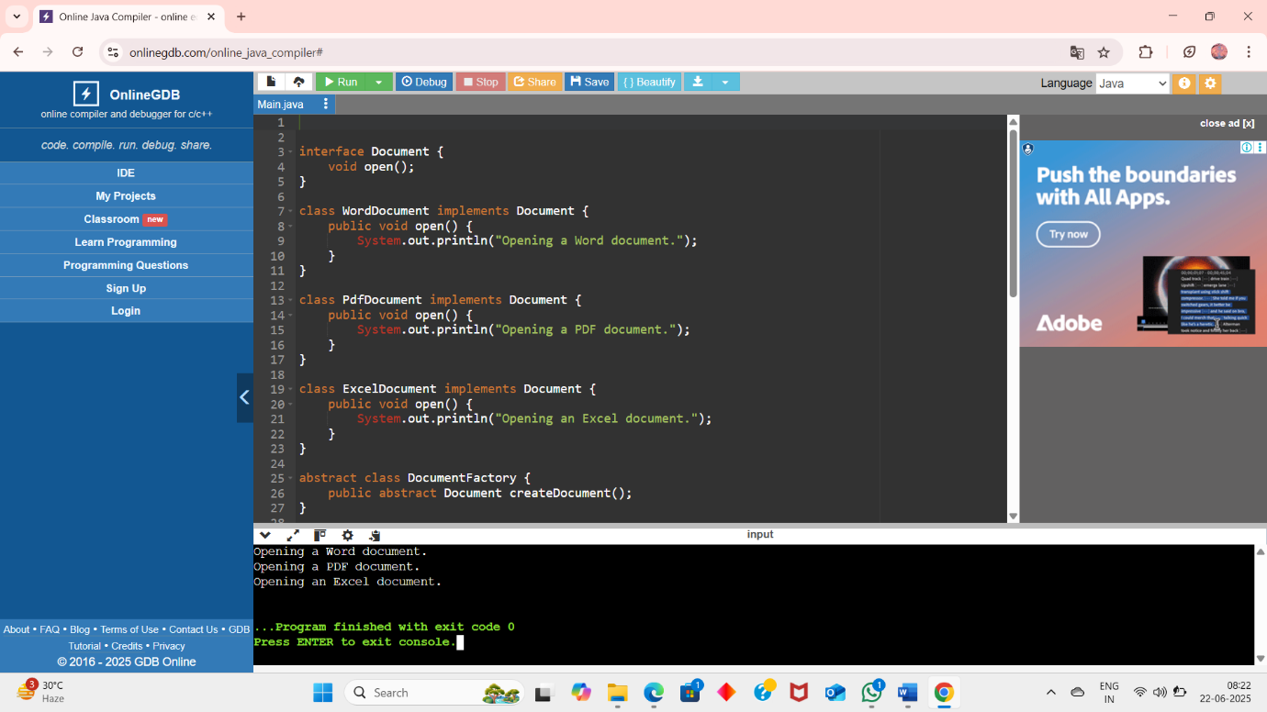

Exercise 3: Implementing the Builder Pattern
Program:

class Computer {

private String CPU;
private String RAM;
private String storage;
private String graphicsCard;
private boolean isBluetoothEnabled;
private boolean isWifiEnabled;

private Computer(Builder builder) {
this.CPU = builder.CPU;
this.RAM = builder.RAM;
this.storage = builder.storage;
this.graphicsCard = builder.graphicsCard;
this.isBluetoothEnabled = builder.isBluetoothEnabled;
this.isWifiEnabled = builder.isWifiEnabled;
}

public static class Builder {
private String CPU;
private String RAM;
private String storage;
private String graphicsCard;
private boolean isBluetoothEnabled;
private boolean isWifiEnabled;

public Builder(String CPU, String RAM) {
this.CPU = CPU;
this.RAM = RAM;
}

public Builder setStorage(String storage) {
this.storage = storage;
return this;
}

public Builder setGraphicsCard(String graphicsCard) {
this.graphicsCard = graphicsCard;
return this;
}

public Builder setBluetoothEnabled(boolean isBluetoothEnabled) {
this.isBluetoothEnabled = isBluetoothEnabled;
return this;
}

public Builder setWifiEnabled(boolean isWifiEnabled) {
this.isWifiEnabled = isWifiEnabled;
return this;
}

public Computer build() {
return new Computer(this);
}
}

public void showConfig() {
System.out.println("Computer Configuration:");
System.out.println("CPU: " + CPU);
System.out.println("RAM: " + RAM);
System.out.println("Storage: " + storage);
System.out.println("Graphics Card: " + graphicsCard);
System.out.println("Bluetooth Enabled: " + isBluetoothEnabled);
System.out.println("WiFi Enabled: " + isWifiEnabled);
System.out.println("--------------------------------");
}
}

public class Main {
public static void main(String[] args) {

Computer basicComputer = new Computer.Builder("Intel i5", "8GB")
.setStorage("256GB SSD")
.build();

Computer gamingComputer = new Computer.Builder("AMD Ryzen 9", "32GB")
.setStorage("1TB SSD")
.setGraphicsCard("NVIDIA RTX 4080")
.setBluetoothEnabled(true)
.setWifiEnabled(true)
.build();

basicComputer.showConfig();
gamingComputer.showConfig();
}
}

Ouput:
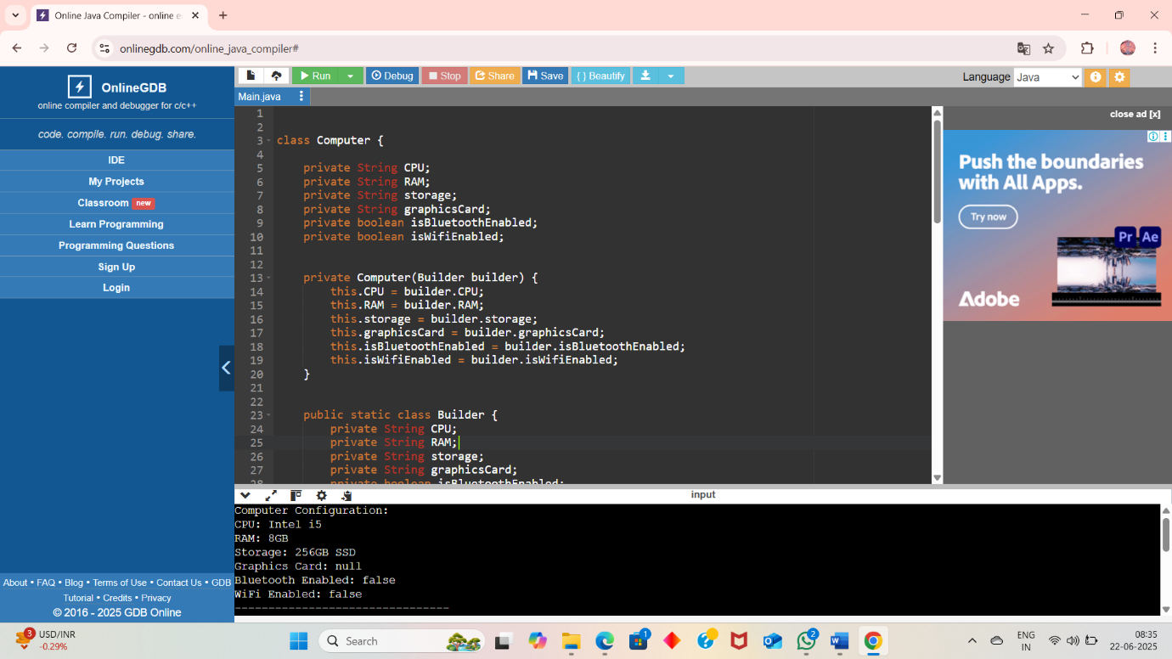

Exercise 4 : Implementing the Adapter Pattern
Program:

interface PaymentProcessor {
void processPayment(double amount);
}

class PayPalGateway {
public void makePayment(double amount) {
System.out.println("Payment of $" + amount + " processed using PayPal.");
}
}

class StripeGateway {
public void executeTransaction(double amount) {
System.out.println("Payment of $" + amount + " processed using Stripe.");
}
}

class SquareGateway {
public void performPayment(double amount) {
System.out.println("Payment of $" + amount + " processed using Square.");
}
}

class PayPalAdapter implements PaymentProcessor {
private PayPalGateway payPal;

public PayPalAdapter(PayPalGateway payPal) {
this.payPal = payPal;
}

public void processPayment(double amount) {
payPal.makePayment(amount);
}
}

class StripeAdapter implements PaymentProcessor {
private StripeGateway stripe;

public StripeAdapter(StripeGateway stripe) {
this.stripe = stripe;
}

public void processPayment(double amount) {
stripe.executeTransaction(amount);
}
}

class SquareAdapter implements PaymentProcessor {
private SquareGateway square;

public SquareAdapter(SquareGateway square) {
this.square = square;
}

public void processPayment(double amount) {
square.performPayment(amount);
}
}

public class Main {
public static void main(String[] args) {

PaymentProcessor paypalProcessor = new PayPalAdapter(new PayPalGateway());
paypalProcessor.processPayment(100.50);

PaymentProcessor stripeProcessor = new StripeAdapter(new StripeGateway());
stripeProcessor.processPayment(250.75);

PaymentProcessor squareProcessor = new SquareAdapter(new SquareGateway());
squareProcessor.processPayment(399.99);
}
}

Output:
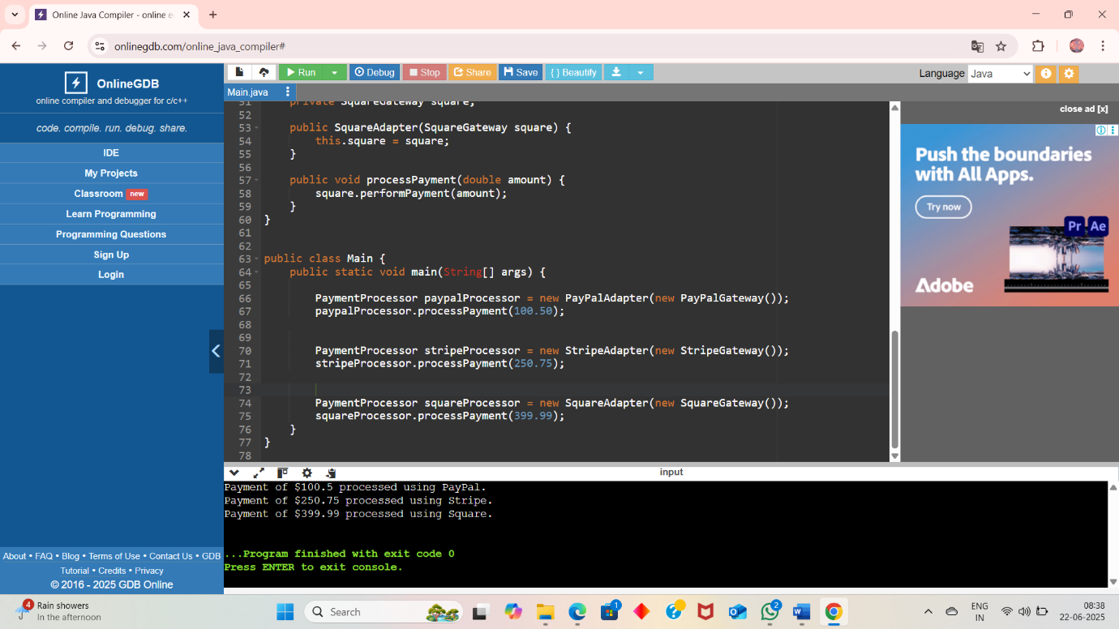

Exercise 5 : Implementing the Decorator pattern
Program :
interface Notifier {
void send(String message);
}

class EmailNotifier implements Notifier {
public void send(String message) {
System.out.println("Email sent: " + message);
}
}

abstract class NotifierDecorator implements Notifier {
protected Notifier notifier;

public NotifierDecorator(Notifier notifier) {
this.notifier = notifier;
}

public void send(String message) {
notifier.send(message);
}
}

class SMSNotifierDecorator extends NotifierDecorator {
public SMSNotifierDecorator(Notifier notifier) {
super(notifier);
}

public void send(String message) {
super.send(message);
sendSMS(message);
}

private void sendSMS(String message) {
System.out.println("SMS sent: " + message);
}
}

class SlackNotifierDecorator extends NotifierDecorator {
public SlackNotifierDecorator(Notifier notifier) {
super(notifier);
}

public void send(String message) {
super.send(message);
sendSlack(message);
}

private void sendSlack(String message) {
System.out.println("Slack message sent: " + message);
}
}

public class Main {
public static void main(String[] args) {

Notifier notifier = new EmailNotifier();
notifier = new SMSNotifierDecorator(notifier);
notifier = new SlackNotifierDecorator(notifier);
notifier.send("System Alert: High CPU Usage Detected!");
}
}

Output:
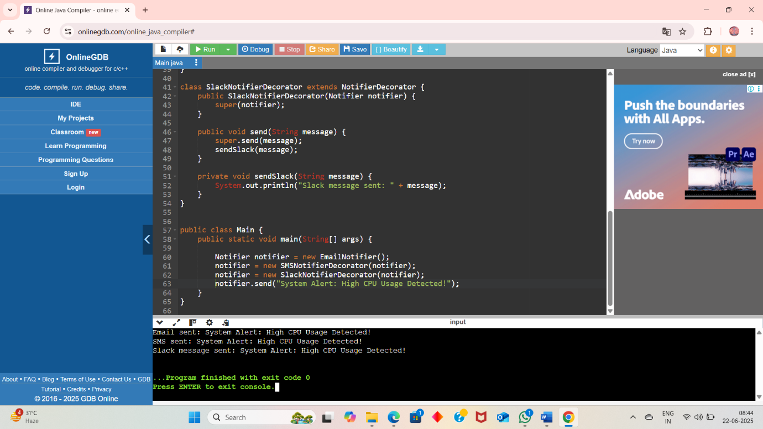

Exercise 6 : Implementing the Proxy Pattern
Program:

interface Image {
void display();
}

class RealImage implements Image {
private String filename;

public RealImage(String filename) {
this.filename = filename;
loadFromRemoteServer();
}

private void loadFromRemoteServer() {
System.out.println("Loading image from remote server: " + filename);
}

public void display() {
System.out.println("Displaying image: " + filename);
}
}

class ProxyImage implements Image {
private RealImage realImage;
private String filename;

public ProxyImage(String filename) {
this.filename = filename;
}

public void display() {
if (realImage == null) {
realImage = new RealImage(filename); // Lazy initialization
} else {
System.out.println("Using cached image: " + filename);
}
realImage.display();
}
}

public class Main {
public static void main(String[] args) {
Image image1 = new ProxyImage("photo1.jpg");
Image image2 = new ProxyImage("photo2.jpg");
image1.display();
image1.display();
image2.display();
}
}

Output:
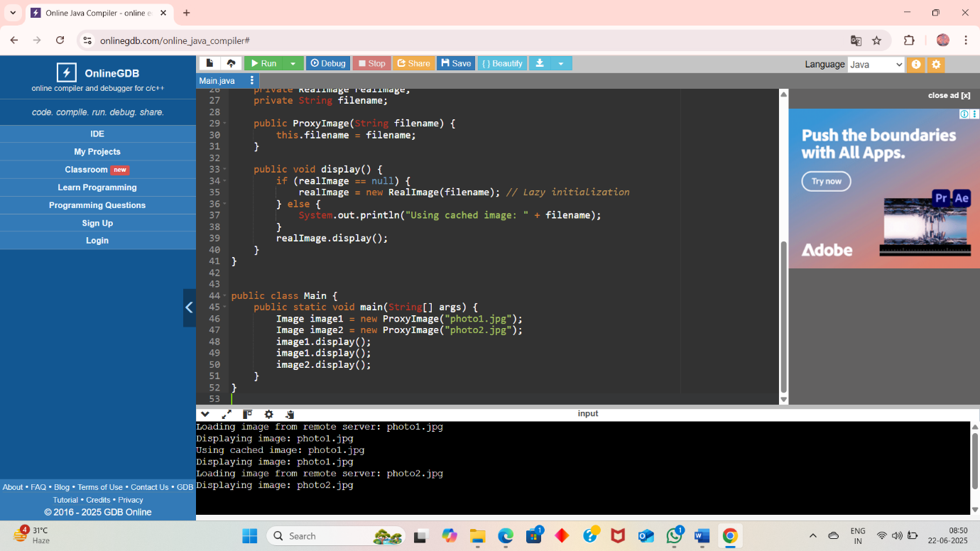

Exercise 7 : Implementing the Observer Pattern
Program:
import java.util.ArrayList;
import java.util.List;

interface Stock {
void registerObserver(Observer o);
void removeObserver(Observer o);
void notifyObservers();
}

interface Observer {
void update(String stockName, double price);
}

class StockMarket implements Stock {
private List<Observer> observers = new ArrayList<>();
private String stockName;
private double price;

public void setStockPrice(String stockName, double price) {
this.stockName = stockName;
this.price = price;
notifyObservers();
}

public void registerObserver(Observer o) {
observers.add(o);
}

public void removeObserver(Observer o) {
observers.remove(o);
}

public void notifyObservers() {
for (Observer o : observers) {
o.update(stockName, price);
}
}
}

class MobileApp implements Observer {
private String user;

public MobileApp(String user) {
this.user = user;
}

public void update(String stockName, double price) {
System.out.println("MobileApp [" + user + "] - " + stockName + " price updated to $" + price);
}
}

class WebApp implements Observer {
private String user;

public WebApp(String user) {
this.user = user;
}

public void update(String stockName, double price) {
System.out.println("WebApp [" + user + "] - " + stockName + " price updated to $" + price);
}
}

public class Main {
public static void main(String[] args) {
StockMarket stockMarket = new StockMarket();
Observer mobileUser1 = new MobileApp("Alice");
Observer webUser1 = new WebApp("Bob");
stockMarket.registerObserver(mobileUser1);
stockMarket.registerObserver(webUser1);
stockMarket.setStockPrice("AAPL", 189.25);
stockMarket.setStockPrice("GOOGL", 2873.50);
stockMarket.removeObserver(mobileUser1);
stockMarket.setStockPrice("AMZN", 3520.75);
}
}

Output:
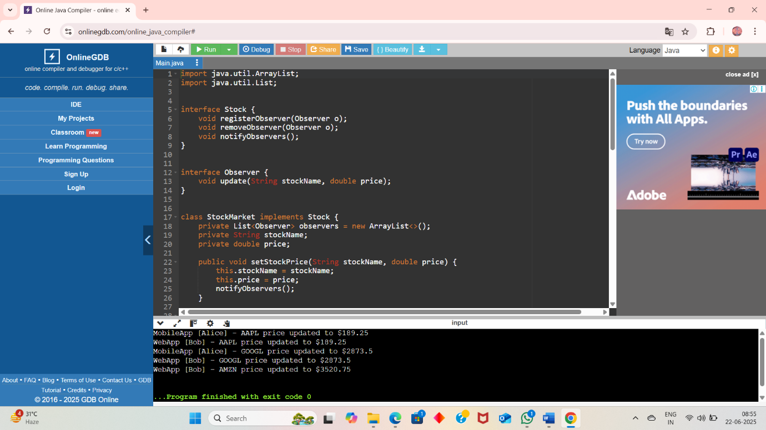

Exercise 8 : Implementing the Strategy Pattern
Program:
interface PaymentStrategy {
void pay(double amount);
}

class CreditCardPayment implements PaymentStrategy {
private String cardNumber;

public CreditCardPayment(String cardNumber) {
this.cardNumber = cardNumber;
}

public void pay(double amount) {
System.out.println("Paid $" + amount + " using Credit Card: " + cardNumber);
}
}

class PayPalPayment implements PaymentStrategy {
private String email;

public PayPalPayment(String email) {
this.email = email;
}

public void pay(double amount) {
System.out.println("Paid $" + amount + " using PayPal account: " + email);
}
}

class PaymentContext {
private PaymentStrategy strategy;

public void setPaymentStrategy(PaymentStrategy strategy) {
this.strategy = strategy;
}

public void processPayment(double amount) {
if (strategy != null) {
strategy.pay(amount);
} else {
System.out.println("No payment strategy selected.");
}
}
}

public class Main {
public static void main(String[] args) {
PaymentContext context = new PaymentContext();
context.setPaymentStrategy(new CreditCardPayment("1234-5678-9012-3456"));
context.processPayment(150.00);
context.setPaymentStrategy(new PayPalPayment("user@example.com"));
context.processPayment(200.50);
}
}

Output:
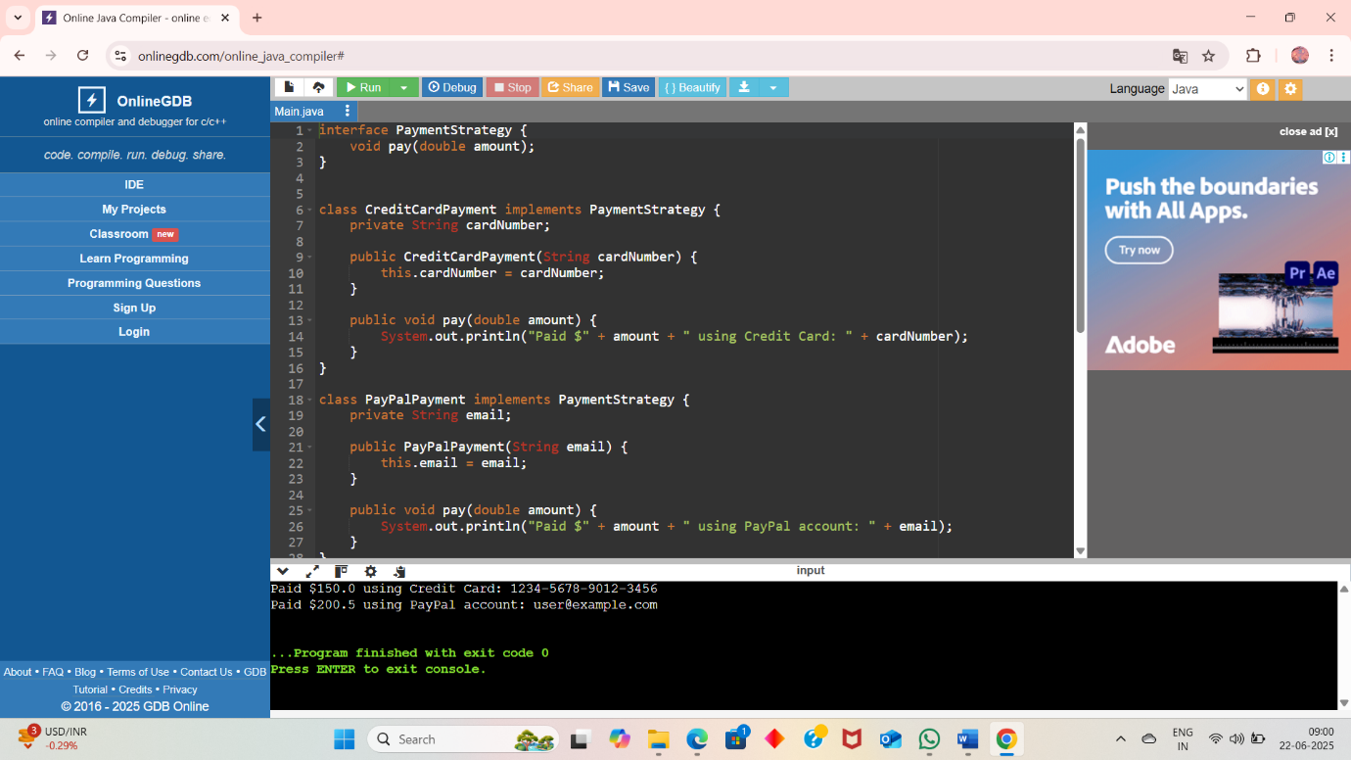

Exercise 9 : Implementing the Command Pattern
Program:
interface Command {
void execute();
}

class Light {
public void turnOn() {
System.out.println("The light is ON.");
}

public void turnOff() {
System.out.println("The light is OFF.");
}
}

class LightOnCommand implements Command {
private Light light;

public LightOnCommand(Light light) {
this.light = light;
}

public void execute() {
light.turnOn();
}
}

class LightOffCommand implements Command {
private Light light;

public LightOffCommand(Light light) {
this.light = light;
}

public void execute() {
light.turnOff();
}
}

class RemoteControl {
private Command command;

public void setCommand(Command command) {
this.command = command;
}

public void pressButton() {
if (command != null) {
command.execute();
} else {
System.out.println("No command set.");
}
}
}

public class Main {
public static void main(String[] args) {
Light livingRoomLight = new Light();
Command lightOn = new LightOnCommand(livingRoomLight);
Command lightOff = new LightOffCommand(livingRoomLight);
RemoteControl remote = new RemoteControl();
remote.setCommand(lightOn);
remote.pressButton();
remote.setCommand(lightOff);
remote.pressButton();
}
}

Output:
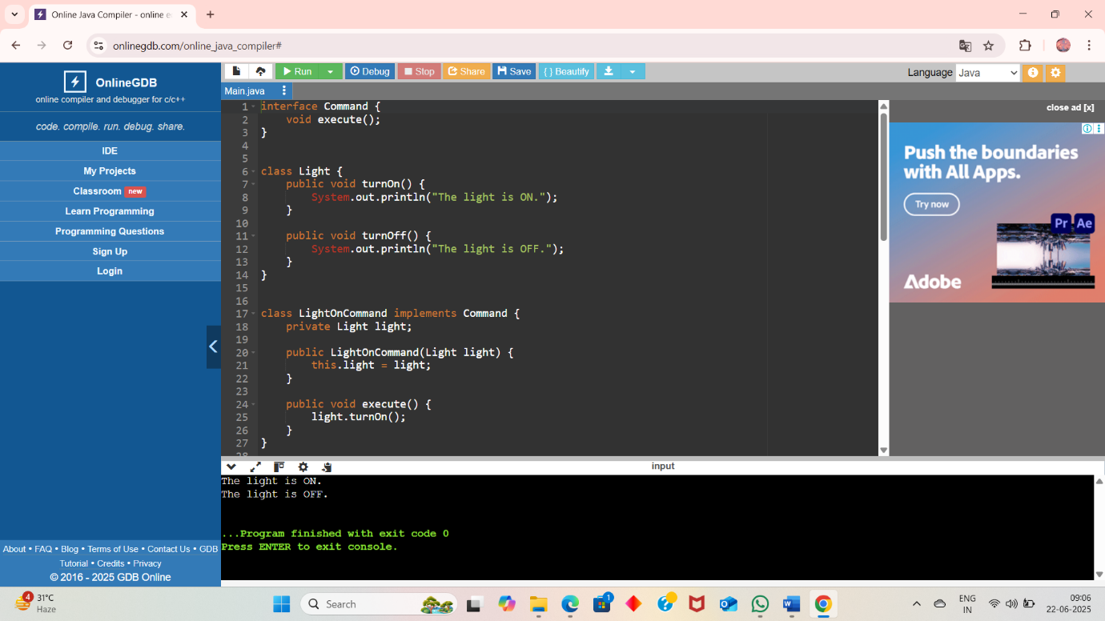

Exercise 10 : Implementing the MVC Pattern
Program:
class Student {
private String name;
private String id;
private String grade;

public Student(String name, String id, String grade) {
this.name = name;
this.id = id;
this.grade = grade;
}

public String getName() {
return name;
}

public void setName(String name) {
this.name = name;
}

public String getId() {
return id;
}

public void setId(String id) {
this.id = id;
}

public String getGrade() {
return grade;
}

public void setGrade(String grade) {
this.grade = grade;
}
}

class StudentView {
public void displayStudentDetails(String name, String id, String grade) {
System.out.println("Student Details:");
System.out.println("Name : " + name);
System.out.println("ID : " + id);
System.out.println("Grade : " + grade);
System.out.println("-------------------------");
}
}

class StudentController {
private Student model;
private StudentView view;

public StudentController(Student model, StudentView view) {
this.model = model;
this.view = view;
}

public void setStudentName(String name) {
model.setName(name);
}

public void setStudentId(String id) {
model.setId(id);
}

public void setStudentGrade(String grade) {
model.setGrade(grade);
}

public void updateView() {
view.displayStudentDetails(model.getName(), model.getId(), model.getGrade());
}
}

public class Main {
public static void main(String[] args) {

Student student = new Student("Alice", "S101", "A");
StudentView view = new StudentView();
StudentController controller = new StudentController(student, view);
controller.updateView();
controller.setStudentName("Bob");
controller.setStudentGrade("B+");
controller.updateView();
}
}

Ouput:
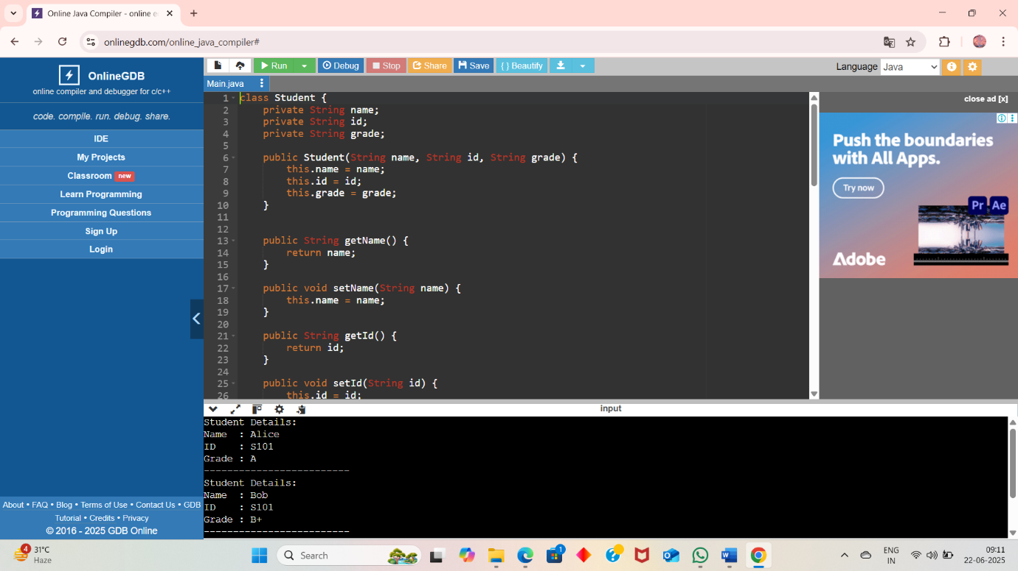

Exercise 11 : Implementing Dependency Injection
Program:
interface CustomerRepository {
Customer findCustomerById(int id);
}

class Customer {
private int id;
private String name;

public Customer(int id, String name) {
this.id = id;
this.name = name;
}

public int getId() { return id; }
public String getName() { return name; }
}

class CustomerRepositoryImpl implements CustomerRepository {

private Customer[] customers = {
new Customer(1, "Alice"),
new Customer(2, "Bob"),
new Customer(3, "Charlie")
};

public Customer findCustomerById(int id) {
for (Customer c : customers) {
if (c.getId() == id) return c;
}
return null;
}
}

class CustomerService {
private CustomerRepository repository;

public CustomerService(CustomerRepository repository) {
this.repository = repository;
}

public void printCustomerDetails(int id) {
Customer c = repository.findCustomerById(id);
if (c != null) {
System.out.println("Customer found: ID=" + c.getId() + ", Name=" + c.getName());
} else {
System.out.println("Customer with ID " + id + " not found.");
}
}
}

public class Main {
public static void main(String[] args) {
CustomerRepository repository = new CustomerRepositoryImpl();
CustomerService service = new CustomerService(repository);
service.printCustomerDetails(2);
service.printCustomerDetails(5);
}
}

Ouput:
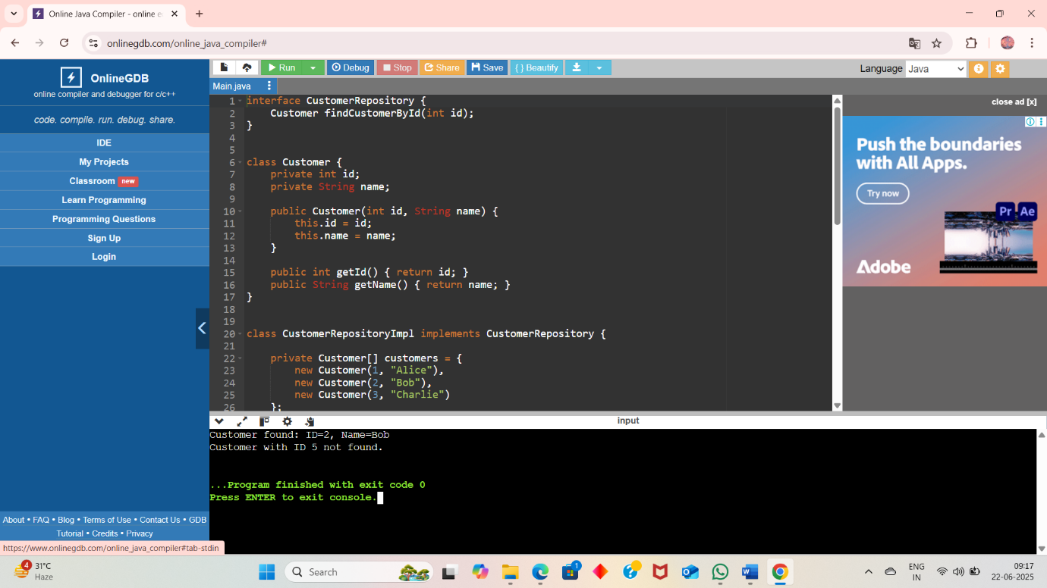

Exercise 2: E-commerce Platform Search Function

import java.util.Arrays;
import java.util.Comparator;

class Product {
int productId;
String productName;
String category;

public Product(int productId, String productName, String category) {
this.productId = productId;
this.productName = productName;
this.category = category;
}

public String toString() {
return "Product ID: " + productId + ", Name: " + productName + ", Category: " + category;
}
}

public class Main {

public static Product linearSearch(Product[] products, int targetId) {
for (Product p : products) {
if (p.productId == targetId) {
return p;
}
}
return null;
}

public static Product binarySearch(Product[] products, int targetId) {
int left = 0;
int right = products.length - 1;
while (left <= right) {
int mid = left + (right - left) / 2;
if (products[mid].productId == targetId) {
return products[mid];
} else if (products[mid].productId < targetId) {
left = mid + 1;
} else {
right = mid - 1;
}
}
return null;
}

public static void main(String[] args) {

Product[] products = {
new Product(101, "Laptop", "Electronics"),
new Product(105, "Shampoo", "Personal Care"),
new Product(102, "Mobile Phone", "Electronics"),
new Product(103, "Table", "Furniture"),
new Product(104, "Shoes", "Fashion")
};

Arrays.sort(products, Comparator.comparingInt(p -> p.productId));
Product result1 = linearSearch(products, 103);
System.out.println("Linear Search Result: " + (result1 != null ? result1 : "Product not found"));
Product result2 = binarySearch(products, 103);
System.out.println("Binary Search Result: " + (result2 != null ? result2 : "Product not found"));
}
}

Output:
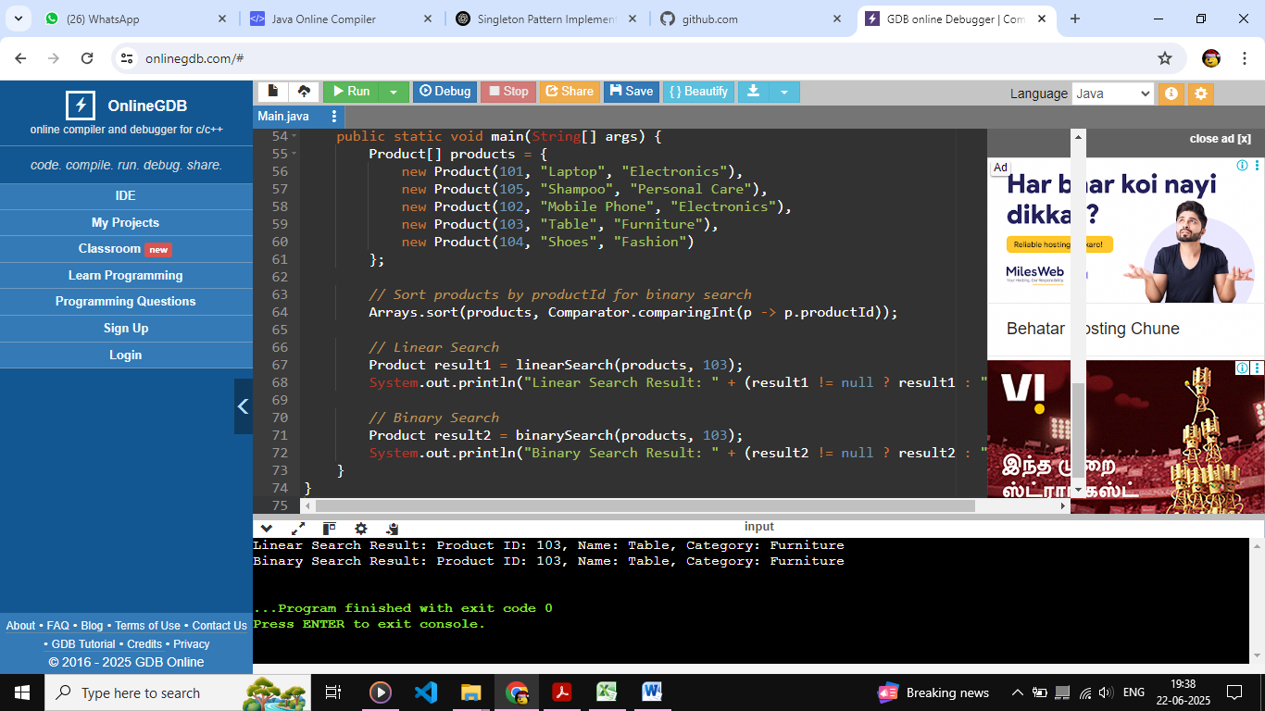

Exercise 7: Financial Forecasting

public class Main {

public static double futureValue(double presentValue, double rate, int years) {
if (years == 0) {
return presentValue;
}
return futureValue(presentValue * (1 + rate), rate, years - 1);
}

public static void main(String[] args) {
double presentValue = 10000;
double rate = 0.08;
int years = 5;
double future = futureValue(presentValue, rate, years);
System.out.printf("Future Value after %d years: ₹%.2f%n", years, future);
}
}

Output:
